**Experiment: 01**

**AIM : Introduction and Installation of Xampp Server on Linux.**

XAMPP

|  |  |  |  |  |  |  |  |  |  |  |  |  |  |
| --- | --- | --- | --- | --- | --- | --- | --- | --- | --- | --- | --- | --- | --- |
| XAMPP is a free and open source cross-platform web server solution developed by Apache Friends, consisting mainly of the Apache HTTP Server, MariaDB database, and interpreters for scripts written in the PHP and Perl programming languages.  XAMPP stands for Cross-Platform (X), Apache (A), MariaDB (M), PHP (P) and Perl (P). It is a simple, lightweight Apache distribution that makes it extremely easy for developers to create a local web server for testing and deployment purposes. Everything needed to set up a web server – server application (Apache), database (MariaDB), and scripting language (PHP) – is included in an extractable file. XAMPP is also cross-platform, which means it works equally well on Linux, Mac and Windows. Since most actual web server deployments use the same components as XAMPP, it makes  transitioning from a local test server to a live server extremely easy as well.  There is no official acronym expansion specified on the Apache Friends website. Their homepage header reads “XAMPP Apache + MariaDB + PHP + Perl”, indicating that this abbreviation is a recursive acronym. | |  |  | | --- | --- | | **Initial Release** | 2002 | | **Latest Version** | 7.2.1 (01-2018) | | **Written in** | Multiple Languages | | **Operating Systems** | * MacOS * Windows * Linux * Solaris | | **License** | GNU General Public License | | **Types** | * WAMP * MAMP * SAMP * LAMP | |

XAMPP Installation:

XAMPP is very easy to install. The setup containing MariaDB, PHP, and Perl. The setup, according to their own point of view is just to download and start the installer. However, in ubuntu, there may be some issues. Follow these steps to install XAMPP in Ubuntu:

# Download a XAMPP distribution for Linux

Go to the official xampp website in the downloads area and choose the latest version. Most all distributions of Linux are supported, including Debian, RedHat, CentOS, Ubuntu, Fedora, Gentoo, Arch, SUSE. The downloaded file is xampp-linux-x64-7.2.1-0-installer.run.

# Proceed with the installation

Probably, if you try to open the downloaded file, a menu that says that you don't have the right program to open this kind of files will appear due to its extension .run. Right Click on the XAMPP setup and select properties from the dropdown menu. Now from the popup select the Permissions tab and check "Allow executing file as Program":

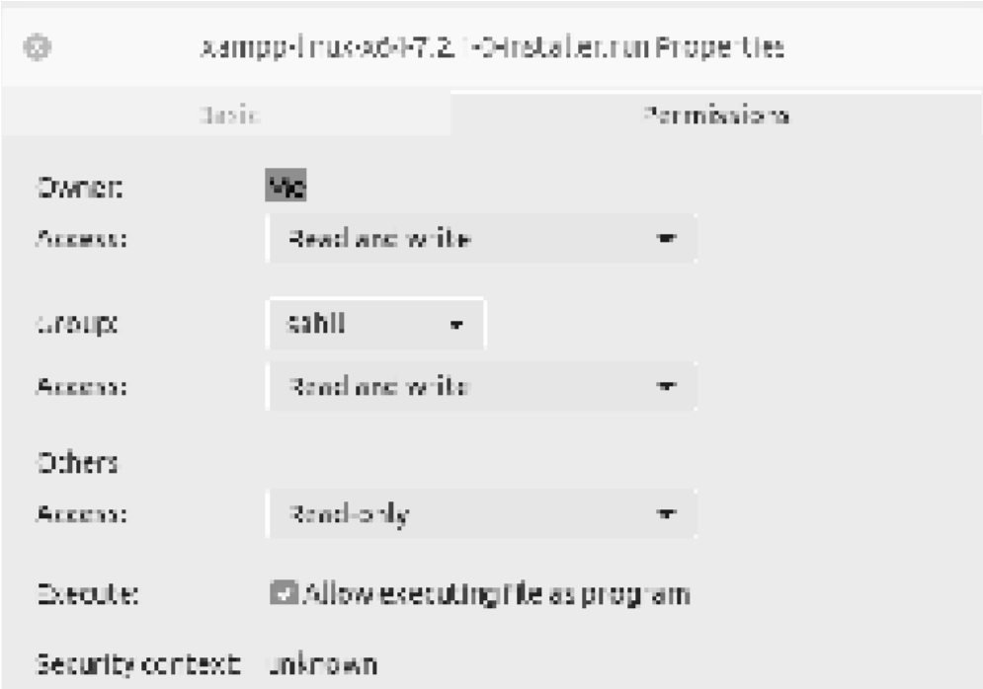

Now, Open a terminal, navigate to the folder where the installer is located and execute it using sudo:

*sudo ./xampp-linux-x64-5.6.24-1-installer.run*

That should start the XAMPP installation setup. Continue with the installation:

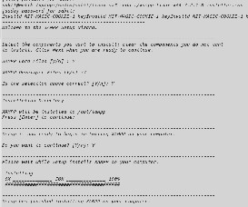

**Xampp setup installation Ubuntu**

Once the setup is finished, XAMPP should be available in Application Drawer. If not, you can create a dot desktop file and place it in */usr/share/applications* dir.

# Test PHPMyAdmin and Apache Web Server

To test everything is setup right, we need to start the MySQL Database and Apache Web Server services in the XAMPP control panel. Open the XAMPP control panel, navigate to the Manage Servers tab.

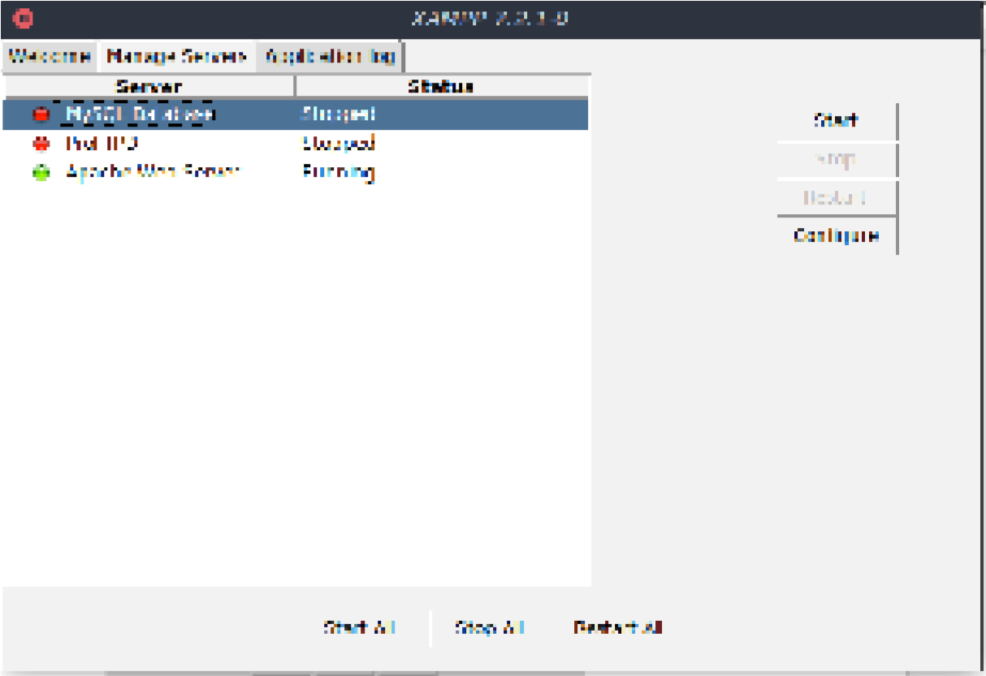

In the Manage Servers tab, a list of services will be present where the previously mentioned services are located. Select individually the services to start and click on Start in the right panel.

**Experiment: 02**

**AIM :Creating a Basic HTML Web Page.**

**Screenshots:**

